Task 6.1p
Data structures and algorithms
Part A: Stack with O(1) Push, Pop, and Min ()
To implement a Stack that supports Push, Pop, and Min operations all in constant time O(1), we can use two stacks:
- Main Stack:
Stores all the elements in the stack as usual.
- Min Stack:
Tracks the minimum element at each level of the Main Stack.
Explanation:
- Push(x):
  - Push x onto the Main Stack.
  - If Min Stack is empty or x ≤ MinStack.top(), push x onto Min Stack.
In other words , when we push a new value, we check if it is smaller than or equal to the current minimum, if yes , we also push it onto the min stack
- Pop():
  - Pop from the Main Stack.
  - If the popped value equals MinStack.top(), also pop from Min Stack.
In other words , when we pop, we remove from both stacks if the popped value is the current minimum.
- Min():
  - Return MinStack.top() (this is always the current minimum).
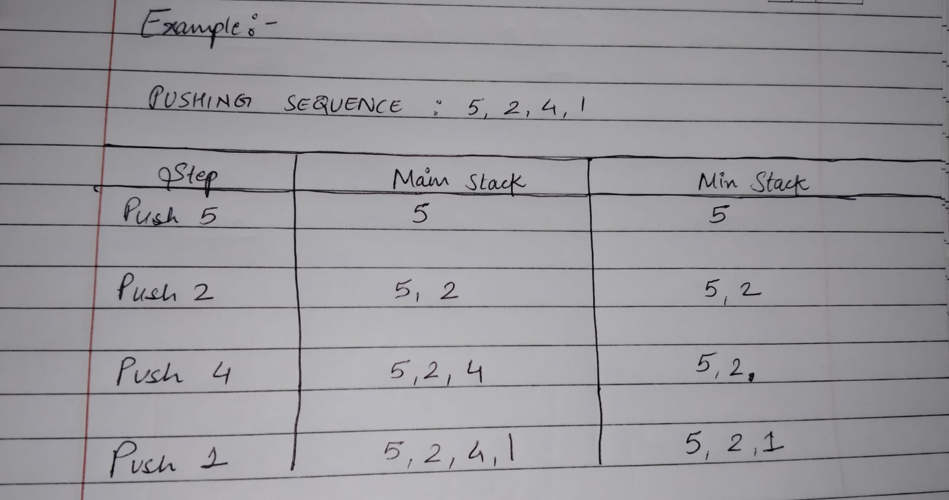
How do we know that the time complexity is O (1)?
- Both Push and Pop affect only the top element of the stacks → O(1).
- We never need to scan through the stack to find the minimum.
- There is no iteration or recursion in any of these operations —
Each action involves either:
Direct access to the top of a stack (array index or linked list head),
A simple comparison,
Or one push/pop action.

Part B : Incorrect Max-Heap DownHeap Implementation Example
Problem with the given pseudocode : In a Max-Heap, the parent should always swap with the largest of both children.
The algorithm should compare left and right children together, then decide.
But here, the pseudocode:
- Ignores the right child completely if the left is bigger (even if the right child is larger than both).
Example heap
3
9
6

LEFT CHILD = 6
RIGHT CHILD = 9 LARGEST
Incorrect DownHeap swaps with 6 (since it checks left first), resulting in:
6

3
9

Invalid, Root should be the largest.
CORRECTED HEAP ,
9
3
6

Part C: DeleteElement(index) in Max-Heap
Procedure RemoveElement(index):
If index < 1 or index > heapSize:
Report "Invalid index"
Exit

If index == heapSize:
Remove the last element
Decrease heapSize by 1
Exit

Replace H[index] with the last element H[heapSize]
Remove last element
Decrease heapSize by 1

If index == 1 or H[index] ≤ H[Parent(index)]:
Call RestoreDown(index) // Push down if needed
Else:
Call RestoreUp(index) // Bubble up if needed

